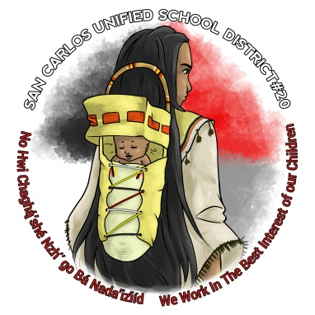
PARENTAL ENGAGEMENT PLAN
SAN CARLOS ALTERNATIVE SCHOOL
2017-2018

San Carlos Unified School District #20

In recognition that the parent is the child’s first and most important teacher, and that the parent’s continued involvement is essential for the success of the child, Rice Elementary School is committed to building a strong parent-school partnership. As a schoolwide Title I school, we involve parents in activities to support the education of our students. To support a strong parent-school partnership, the following policies were developed in consultation with parents to ensure that parents are involved in planning, implementing, and evaluating the Title I program:

- Parents will be invited to participate in an annual meeting in the fall of each school year during which the programs and activities funded with Title I funds are explained. A notice of the Title I meeting will be sent to each family.
- Opportunities to participate in parent involvement activities will be made available at flexible times including morning, evening, and Saturday activities. Staff will provide opportunities for additional meetings if requested by parents.
- Meetings provide parents information about programs, curriculum, assessments, measurement of progress, and proficiency levels students are expected to meet. Meetings provide opportunities for equal access for parents who are ELL, migrant, homeless, or disabled. Meetings provide information to parents in a uniform format and in a language parents can understand.

- Parents have the right to be involved in Title I decision making and policy development. They will be involved in planning, reviewing and improving the Title I Parent and Family Engagement Plan in a timely fashion. Parents are full partners in their child’s education and are included, as appropriate, in decision-making through the Site Council and advisory committees to support the education of the students. Parents will be informed of their rights to be involved in Title I planning, decision-making, and policy development.

- Parents will be involved in planning and implementing Schoolwide and School Improvement Plans and a rebuttal process. They will participate in an annual review and revision of the plans in order to keep them current.

- Parents will be involved in developing and supporting a School-Parent Compact that defines the shared responsibilities of teachers, parents, and students to the academic achievement. The goal is to ensure understanding and cooperation among the parents, students, and respective school officials necessary for the child to profit fully from all school experiences. The compact will be signed by teachers, parents, and students and used to affirm their partnership. The Compact will be reviewed annually and revised as necessary. Teachers will review the School-Parent Compact with parents as it relates to individual student achievement. The Compact will describe the process for ongoing communication to discuss the Compact relating to student achievement including:

  - The school’s responsibility to provide high quality curriculum and instruction.
  - Teachers’ responsibility to report to parents quarterly on each child’s academic progress and will send other reports as necessary to keep parents informed.
  - The parents’ responsibility to support their child’s learning by ensuring attendance and completion of homework, restricting television, volunteering at school, and participating in decision-making..
  - Parents’ opportunities to participate in regularly scheduled parent-teacher conferences during which parents and teachers will review student progress and plan together for supporting learning.
  - Parents’ opportunities to visit in their child’s classroom and observe the teaching/ learning process.
  - Furthermore, parents’ communication with their child’s teacher(s) at any time during the school year.

- The school will provide a Parent Involvement Coordinator to implement strategies for building parental involvement and for ongoing communication/coordination of parent involvement activities.

- Communication to parents will be in a language they understand and will be disseminated so that parents of ELL, homeless, migrant, and disabled students have equal opportunities to participate in activities to support student learning.

